Singapore: Recent Economic Developments and Outlook

# GDP growth in 2019 picked up

GDP growth picked up by 0.7% year-on-year (yoy) in 2019. On the demand side, private consumption (36.0% of GDP) contributed the most to growth, with 1.3 percentage points (pp). On the supply side, services (70.4% of GDP) contributed the most to growth, with 0.9pp.

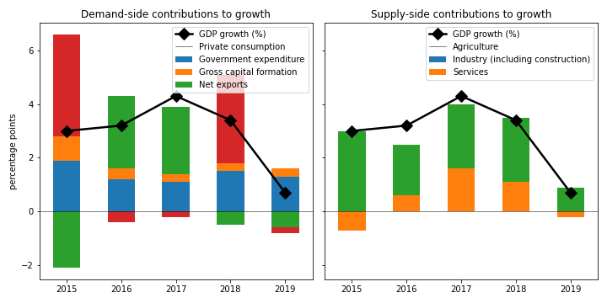

## Private consumption grew the fastest on the demand side

Private consumption grew by the largest margin (3.7%). Government expenditure expanded by 2.8%. On the other hand, gross capital formation declined by 2.2%. On the other hand, net exports shrank by 2.2%.

## On the supply side, agriculture increased the fastest

Agriculture increased the most rapidly (5.1%). Services picked up by 1.3%. On the other hand, industry (including construction) plunged by 0.7%.

## Unemployment declined; inflation increased

Unemployment declined from nan% in 2018 to 3.1% in 2019, while inflation increased from 0.4% to 0.6%.

## Current account balance surplus

The current account balance (CAB) recorded a surplus at 17.0% of GDP in 2019, compared to 17.2% in 2018.

China is the top export destination (13.2% of exports in 2019). Other major exports partners include China, Hong Kong SAR (11.4%), Malaysia (10.5%), and USA (8.8%). Top export products are electrical machinery and equipment and parts thereof; sound recorders and reproducers; television image and sound recorders and reproducers, parts and accessories of such articles (30.9% of exports).

Top imports origins are China (13.7%), USA (12.2%), Malaysia (11.6%), and Other Asia, nes (9.0%). Major import commodities are electrical machinery and equipment and parts thereof; sound recorders and reproducers; television image and sound recorders and reproducers, parts and accessories of such articles(27.3% of imports).

# Output contracted in Q3 2020

Output plunged by 5.6% yoy in Q3 2020 (-13.3% in the previous quarter). Gross capital formation slowed down by the largest margin at -17.4% yoy. Household consumption contracted by 13.7%.

## Leading indicators

Retail sales shrank by 3.6% yoy in December (-8.5% yoy in November).

# Outlook favorable this year

As of January 2021, Consensus Economics panelists project economic growth ending at 5.9% in 2021, while in 2022, the panelists foresee growth at 4.3%. Over the same period, consumption is expected to change by 8.2% and 4.7%, while investment is projected to change by 6.9% and 5.3%. Industrial production is seen to change by 4.8% and 4.0%. Finally, Consensus Economics foresee inflation at 0.9% in 2021 and 1.2% in 2022.

*Sources: Consensus Economics, The World Bank, UN Comtrade, Haver Analytics, and National Sources. Accessed 06 February 2021.*